Multi-Class Network Intrusion Detection on the CICIDS2017 Dataset: A Comparative Study of Five Classification Algorithms under Different Train-Test Splits
Sahil Khedkar  Department of CSE  JAIN (Deemed-to-be University)  Bengaluru, India.  juug24btech20346@jainuniversity.ac.in | Swagat Chand  Department of CSE  JAIN (Deemed-to-be University)  Bengaluru, India.  juug24btech19195@jainuniversity.ac.in
Vishal Sharma  Department of CSE  JAIN (Deemed-to-be University)  Bengaluru, India. | Aditya Yadav  Department of CSE  JAIN (Deemed-to-be University)  Bengaluru, India.

Abstract. Intrusion detection systems must separate malicious network flows from normal traffic and also name the attack type, yet many studies report only overall accuracy on heavily imbalanced data. This paper evaluates five supervised classifiers - Decision Tree, Random Forest, Logistic Regression, Linear Discriminant Analysis (LDA) and Gaussian Naïve Bayes - for 11-class intrusion detection on about 1.3 million flows taken from the Tuesday, Wednesday and Thursday-morning files of the CICIDS2017 dataset. Each model is trained and tested with stratified 70:30, 50:50 and 30:70 train-test splits, which gives 15 experimental runs, and is judged by accuracy, train and test error, weighted and macro precision, recall and F1-score, and row-normalised confusion matrices. Missing and infinite values are replaced by the training-set median, and features are standardised for Logistic Regression. The Decision Tree gave the best result, with 99.90% accuracy and a macro F1-score of 0.868 at the 70:30 split; Random Forest matched its accuracy (99.90% at 50:50) but had a lower macro F1-score. Logistic Regression (98.1-98.2%), LDA (90.6-90.9%) and Gaussian Naïve Bayes (about 30%) were far behind, and their almost identical train and test errors show underfitting. Accuracy also hides the weakness of every model on the three rare web-attack classes. Finally, the best result is compared with five of the best IEEE Xplore papers found in the literature survey.
Keywords: Intrusion detection · CICIDS2017 · Machine learning · Decision tree · Multi-class classification.

1 Introduction
Networks are attacked every day, and an intrusion detection system (IDS) is one of the main tools used to find and report such activity. Rule-based (signature) systems detect only attacks they already know, so machine learning (ML) is widely used to learn the difference between normal and malicious flows directly from labelled traffic [1,3].
The CICIDS2017 dataset, released by the Canadian Institute for Cybersecurity, is one of the most used benchmarks because it contains realistic benign traffic and many modern attacks. It is, however, strongly imbalanced: benign flows and a few large DoS classes dominate, while some attacks, such as SQL injection and Heartbleed, have only a handful of flows. On such data overall accuracy can look excellent even when whole attack classes are missed, and the dataset itself has known labelling problems [6]. A fair comparison of classifiers therefore needs class-level metrics as well as accuracy.
This paper compares five classical classifiers on an 11-class version of CICIDS2017 built from three of its daily files, and repeats every experiment with three train-test ratios. The main contributions are: (i) 15 controlled runs of Decision Tree, Random Forest, Logistic Regression, LDA and Gaussian Naïve Bayes under one common pre-processing pipeline; (ii) an evaluation that reports weighted and macro metrics and per-class recall in addition to accuracy and error; (iii) an analysis of how the training share affects each model; and (iv) a comparison of the best result with five of the best IEEE Xplore papers found in the survey.
The rest of the paper is organised as follows. Section 2 reviews related work, Section 3 describes the proposed work, Section 4 presents and discusses the results, and Section 5 concludes.

2 Literature Survey
Fifteen research papers published in IEEE Xplore that apply machine learning to intrusion detection were reviewed, with attention to the method used and the accuracy achieved. Ustebay et al. [1] ranked CICIDS2017 features with random-forest-based recursive feature elimination and passed the selected features to a deep multilayer perceptron, which detected intrusions with 91% accuracy. Abdulhammed et al. [2] reduced the feature space from 81 to 10 dimensions with principal component analysis (PCA), trained Random Forest, Bayesian network, LDA and QDA classifiers, and added a uniform-distribution balancing step; accuracy stayed at 99.6% for both binary and multi-class classification.
Kurniabudi et al. [3] ranked features by information gain and tested Random Forest, Bayes Net, Random Tree, Naïve Bayes and J48. Random Forest reached 99.86% accuracy with 22 features, and J48 reached 99.87% with 52 features but needed longer execution time. Maseer et al. [4] benchmarked ten supervised and unsupervised algorithms (31 models) on the multi-class CICIDS2017 data and found that the k-NN, decision tree and Naïve Bayes models gave the best results and were better at detecting web attacks. Das et al. [5] combined ensemble supervised learning with ensemble feature selection on NSL-KDD, UNSW-NB15 and CICIDS2017, and reported that 99.3% of intrusions were detected with 0.5% false alarms.
Engelen et al. [6] did not propose a classifier but re-examined CICIDS2017 itself. They found problems in traffic generation, flow construction, feature extraction and labelling, rebuilt or relabelled more than 20% of the traffic traces, and showed that ML benchmarks improved markedly on the corrected data. Yang et al. [7] proposed MTH-IDS, a multi-tiered hybrid system that uses decision tree, random forest, extra trees and XGBoost with Bayesian hyper-parameter optimisation for known attacks and a clustering-based anomaly detector for unknown ones; it reached 99.88% accuracy on CICIDS2017. Halbouni et al. [8] built a hybrid CNN-LSTM network and trained it on CIC-IDS2017, UNSW-NB15 and WSN-DS; on CIC-IDS2017 the authors report 99.64% (binary) and 99.60% (multi-class) accuracy. Sadhwani et al. [9] applied min-max normalisation, the chi-squared test and PCA, split the data 60:20:20 with stratification, and obtained 94.3% with a Support Vector Machine and 99.8% with Decision Tree and Random Forest.
Three observations follow from these papers. First, tree-based and ensemble models usually give the highest accuracy, between 99.6% and 99.9%, while simple probabilistic or linear models are weaker [2,3,4,9]. Second, most papers improve results through feature selection, dimensionality reduction or resampling such as SMOTE [10,11,14,15], and report accuracy rather than macro-averaged metrics. Third, the quality of the benchmark labels matters [6]. The five papers with the highest reported accuracy are summarised in Table 1 and are used for the comparison in Section 4.
Karatas et al. [10] built six IDSs with k-NN, Random Forest, Gradient Boosting, AdaBoost, Decision Tree and LDA on the CSE-CIC-IDS2018 dataset and used SMOTE to reduce class imbalance; they report a considerably higher detection rate for rarely encountered intrusions but give no single accuracy figure in the abstract. Liu et al. [11] proposed the Difficult Set Sampling Technique (DSSTE), which uses the Edited Nearest Neighbour algorithm to split the training set into a difficult and an easy part and K-Means to compress the majority class; tested with RF, SVM, XGBoost, LSTM, AlexNet and Mini-VGGNet on NSL-KDD and CSE-CIC-IDS2018, it outperformed 24 other methods. Ogodo and Osa [12] compared six classifiers on binary CICIDS2017 data with an 80:20 split after Random-Forest-based feature selection (79 to 20 features): XGBoost and k-NN reached 98.3%, Decision Tree 98.1% and QDA only 63.9%, and the Decision Tree was judged best overall because it trained in a few seconds.
Rachini et al. [13] evaluated five tree-based and ensemble classifiers and reported 99.88% for Random Forest, 99.86% for Extremely Randomised Trees, 99.80% for Decision Tree, 99.76% for Gradient Boosting and 90.00% for AdaBoost. Ali et al. [14] combined BERT-based feature representations, SMOTE and a multi-layer perceptron to cope with class imbalance and report very high accuracy on several benchmark datasets. Pavithra et al. [15] proposed a hybrid IDS for unbalanced traffic that uses XGBoost, LSTM, Mini-VGGNet and AlexNet, with a Random Forest regressor ranking the importance of features. The abstracts of [10], [11], [14] and [15] give no single accuracy value, so these four papers are not ranked in Table 1.
Table 1. Five best papers from the literature survey (ranked by reported accuracy).
Ref. | Paper (authors, venue, year) | Methodology | Accuracy (%)
[7] | Yang, Moubayed, Shami; IEEE Internet of Things J., 2021 | MTH-IDS: DT, RF, ET and XGBoost with Bayesian optimisation and stacking; clustering-based anomaly tier | 99.88
[13] | Rachini et al.; IEEE ACIT, 2023 | Five tree-based and ensemble classifiers (RF, ET, DT, GB, AdaBoost) | 99.88 (RF); 99.86 (ET)
[3] | Kurniabudi et al.; IEEE Access, 2020 | Information-gain feature ranking; RF (22 features) and J48 (52 features) | 99.87 (J48); 99.86 (RF)
[9] | Sadhwani et al.; IEEE ASET, 2024 | Min-max scaling, chi-squared and PCA; SVM, DT and RF; 60:20:20 stratified split | 99.8 (DT, RF); 94.3 (SVM)
[8] | Halbouni et al.; IEEE Access, 2022 | Hybrid CNN-LSTM deep network | 99.64 (binary); 99.60 (multi-class)

3 Proposed Work

3.1 Objectives
The proposed work has four objectives: (i) to compare five supervised classifiers for multi-class intrusion detection on the same data and pipeline; (ii) to measure how the train-test ratio (70:30, 50:50, 30:70) changes each model; (iii) to look beyond accuracy by using macro-averaged metrics and per-class recall; and (iv) to compare the best result with five of the best published results.

3.2 Dataset
The experiments use CICIDS2017 (https://www.unb.ca/cic/datasets/ids-2017.html), a flow-based dataset in which each record has 78 numerical features extracted from captured traffic and a class label. Three daily files were combined: Tuesday-WorkingHours (benign, FTP-Patator, SSH-Patator), Wednesday-workingHours (benign, four DoS variants and Heartbleed) and Thursday-WorkingHours-Morning-WebAttacks (benign and three web attacks). Together they hold about 1.3 million flows in 11 classes: BENIGN, DoS GoldenEye, DoS Hulk, DoS Slowhttptest, DoS slowloris, FTP-Patator, Heartbleed, SSH-Patator and the web attacks Brute Force, SQL Injection and XSS. The class distribution is highly skewed, and the web-attack classes, especially SQL Injection, have very few flows.

3.3 Pre-processing
The three files are concatenated and the column names are stripped of spaces. All feature columns are converted to numbers, and positive and negative infinity values are replaced by missing values. The class labels are integer-encoded with LabelEncoder. The data are split with train_test_split using stratification on the class label and a fixed random seed of 0, so every class appears in both parts in the same proportion. Missing values are filled with the median of the training part only, which prevents information from the test part from leaking into the model. Features are standardised (zero mean, unit variance) for Logistic Regression only, because the other four models do not need scaling.

3.4 Classification models
Five scikit-learn classifiers are used with the settings in Table 2. All imputation, scaling and model fitting are wrapped in one pipeline so that each step is fitted on the training part alone.
Table 2. Classifiers and settings used in the experiments.
Classifier | Main settings
Decision Tree | Entropy criterion, unlimited depth, random_state = 0
Random Forest | 50 trees, entropy criterion, random_state = 0
Logistic Regression | Standardised inputs, max_iter = 200, random_state = 0
Linear Discriminant Analysis | Default scikit-learn settings (SVD solver)
Gaussian Naïve Bayes | Default scikit-learn settings

3.5 Evaluation metrics
Let N be the number of test flows, C = 11 the number of classes, and n_c the number of test flows of class c. The error rate is one minus accuracy. For each class, precision, recall and F1-score are computed from the true positives (TP), false positives (FP) and false negatives (FN):
Accuracy = N_{correct} / N, Error = 1 − Accuracy (1)
P_{c} = TP_{c} / (TP_{c} + FP_{c}), R_{c} = TP_{c} / (TP_{c} + FN_{c}) (2)
F1_{c} = 2P_{c}R_{c} / (P_{c} + R_{c}) (3)
Macro-F1 = (1/C) Σ F1_{c}, Weighted-F1 = Σ (n_{c}/N) F1_{c} (4)
Macro averages give every class the same weight, so rare attack classes strongly affect them. Weighted averages follow the class sizes and are close to accuracy on imbalanced data. Both are reported, together with the row-normalised confusion matrix.

3.6 Proposed algorithm and workflow
Fig. 1 shows the workflow as a flowchart and Algorithm 1 gives the complete procedure.
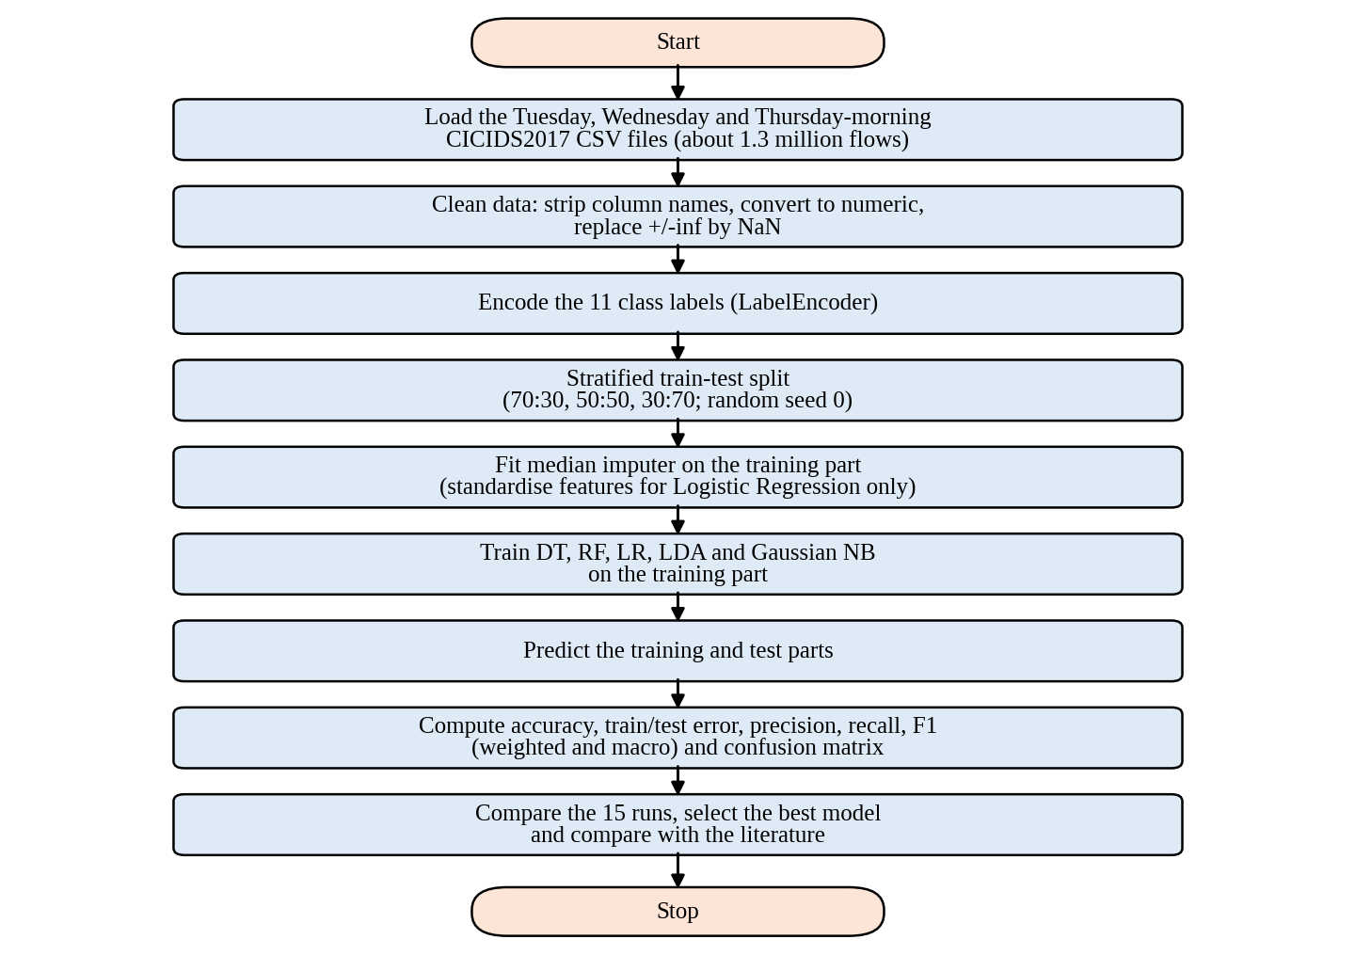
Fig. 1. Flowchart of the proposed experimental workflow.
Algorithm 1. Multi-class intrusion detection experiment.
Input: CICIDS2017 files F; test sizes T = {0.3, 0.5, 0.7}; classifiers M = {DT, RF, LR, LDA, GNB}
Output: accuracy, train/test error, precision, recall, F1 and confusion matrix for every (m, t)
1. Load and concatenate the files in F; strip column names
2. Convert features to numeric; replace ±inf by NaN; encode labels as y
3. for each test size t in T do
4. Split into (X_train, y_train) and (X_test, y_test), stratified on y, seed = 0
5. for each classifier m in M do
6. Build pipeline: median imputer → (scaler, for LR only) → m
7. Fit the pipeline on (X_train, y_train)
8. Predict on X_train and X_test
9. Compute train error, test error, weighted and macro P/R/F1, confusion matrix
10. end for
11. end for
12. Rank the 15 runs, select the best model and compare it with the literature [3,7,8,9,13]

4 Results and Discussion

4.1 Experimental results
All models were implemented in Python with scikit-learn and evaluated on the held-out test part. Table 3 lists all 15 runs. Figs. 2-6 show the accuracy, weighted F1-score and macro F1-score of each algorithm for the three splits, and Figs. 7 and 8 give the overall comparison of all algorithms.
Table 3. Results of all 15 runs (test part). Train error is measured on the training part.
Algorithm | Train:test | Accuracy (%) | Train error | Test error | Macro F1
Decision Tree | 70:30 | 99.90 | 0.0001 | 0.0010 | 0.868
 | 50:50 | 99.90 | 0.0001 | 0.0010 | 0.853
 | 30:70 | 99.89 | 0.0001 | 0.0011 | 0.851
Random Forest | 70:30 | 99.89 | 0.0001 | 0.0011 | 0.845
 | 50:50 | 99.90 | 0.0001 | 0.0010 | 0.848
 | 30:70 | 99.88 | 0.0001 | 0.0012 | 0.833
Logistic Regression | 70:30 | 98.21 | 0.0177 | 0.0179 | 0.660
 | 50:50 | 98.17 | 0.0183 | 0.0183 | 0.644
 | 30:70 | 98.11 | 0.0193 | 0.0189 | 0.636
LDA | 70:30 | 90.56 | 0.0939 | 0.0944 | 0.450
 | 50:50 | 90.76 | 0.0919 | 0.0924 | 0.456
 | 30:70 | 90.88 | 0.0915 | 0.0912 | 0.455
Gaussian NB | 70:30 | 30.15 | 0.6984 | 0.6985 | 0.226
 | 50:50 | 29.91 | 0.7009 | 0.7009 | 0.209
 | 30:70 | 30.03 | 0.6987 | 0.6997 | 0.218

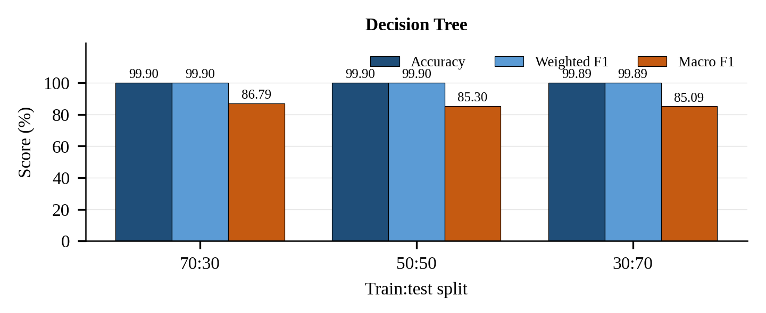
Fig. 2. Decision Tree: accuracy, weighted F1-score and macro F1-score for the three train:test splits.
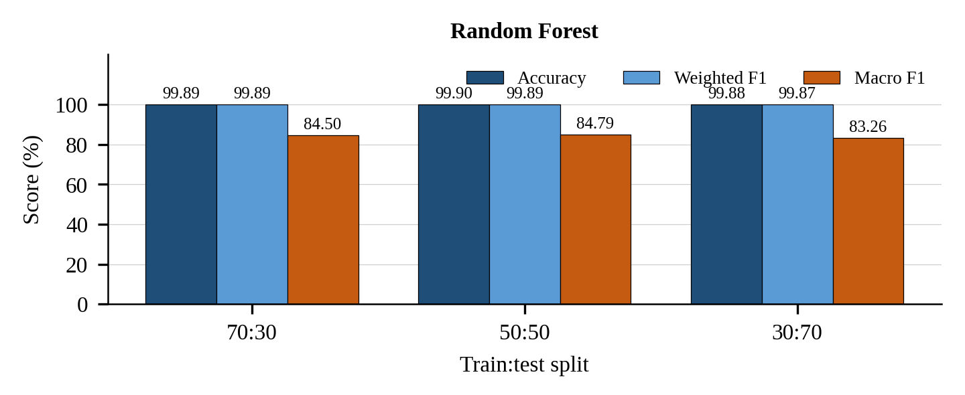
Fig. 3. Random Forest: accuracy, weighted F1-score and macro F1-score for the three train:test splits.
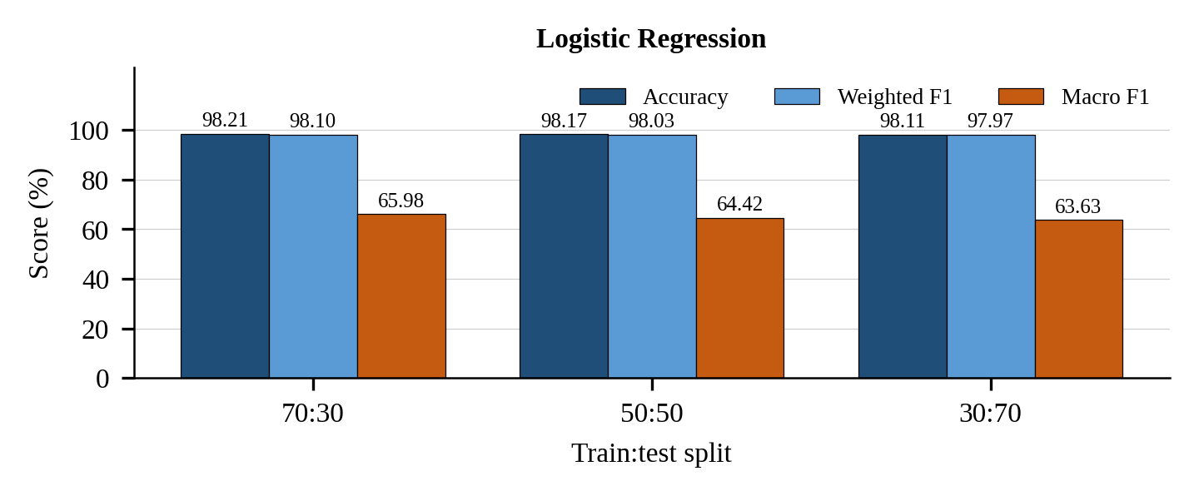
Fig. 4. Logistic Regression: accuracy, weighted F1-score and macro F1-score for the three train:test splits.
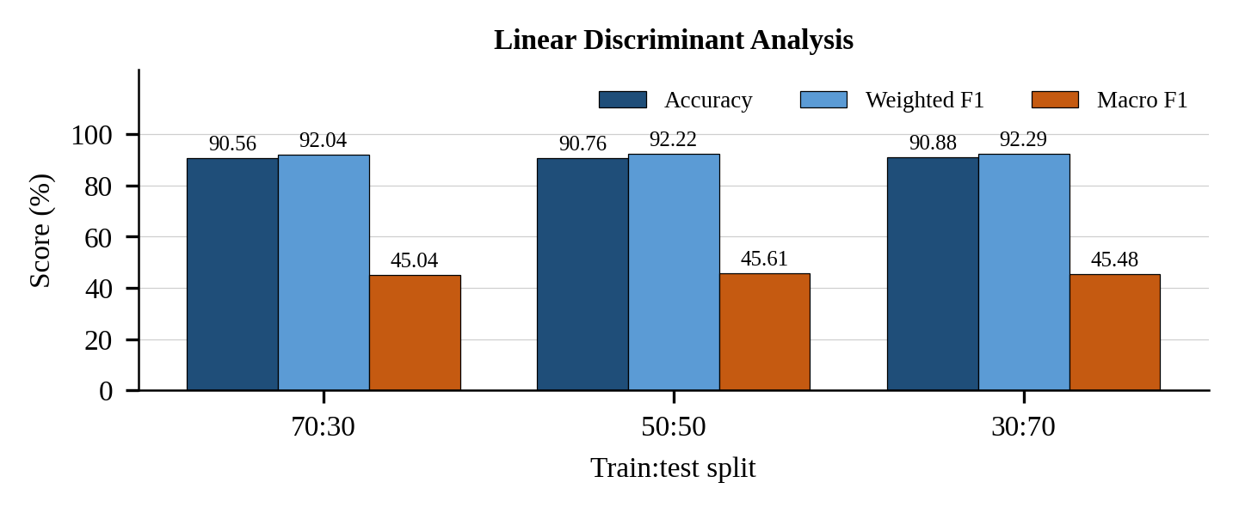
Fig. 5. Linear Discriminant Analysis: accuracy, weighted F1-score and macro F1-score for the three train:test splits.
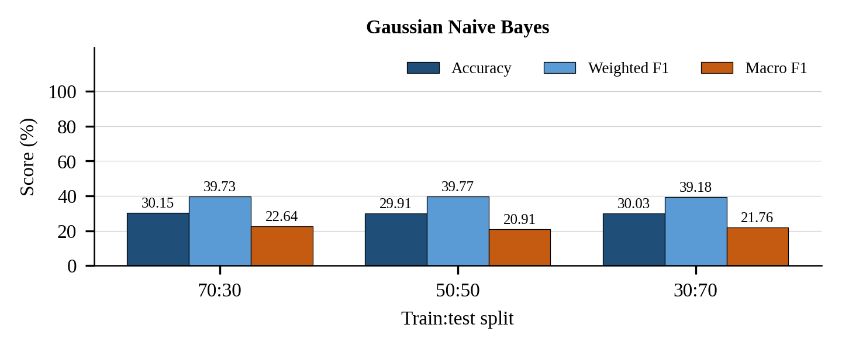
Fig. 6. Gaussian Naïve Bayes: accuracy, weighted F1-score and macro F1-score for the three train:test splits.
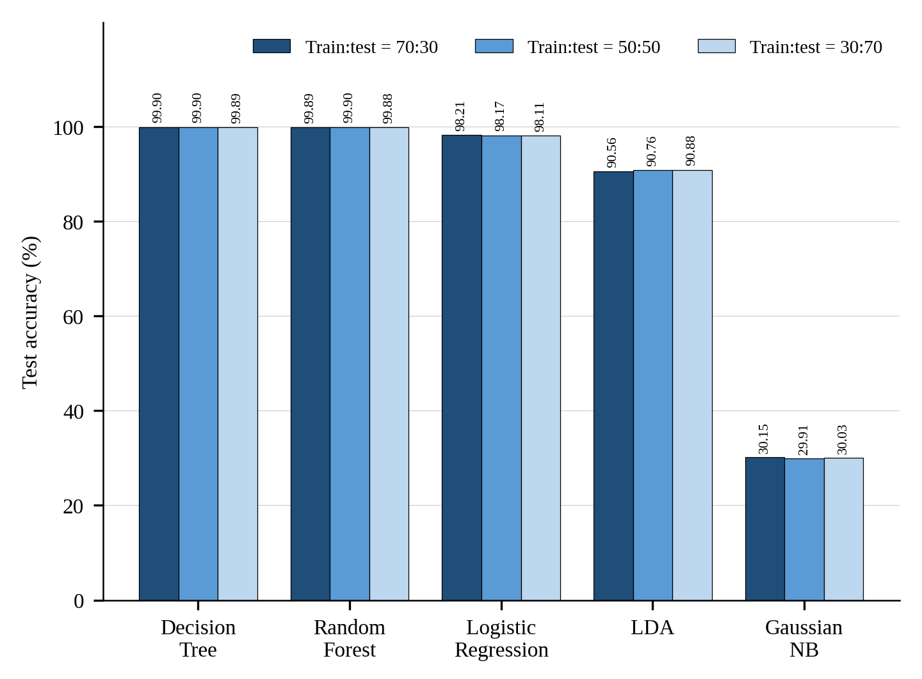
Fig. 7. Overall comparison: test accuracy of all five algorithms for the three train:test ratios (all 15 executions).
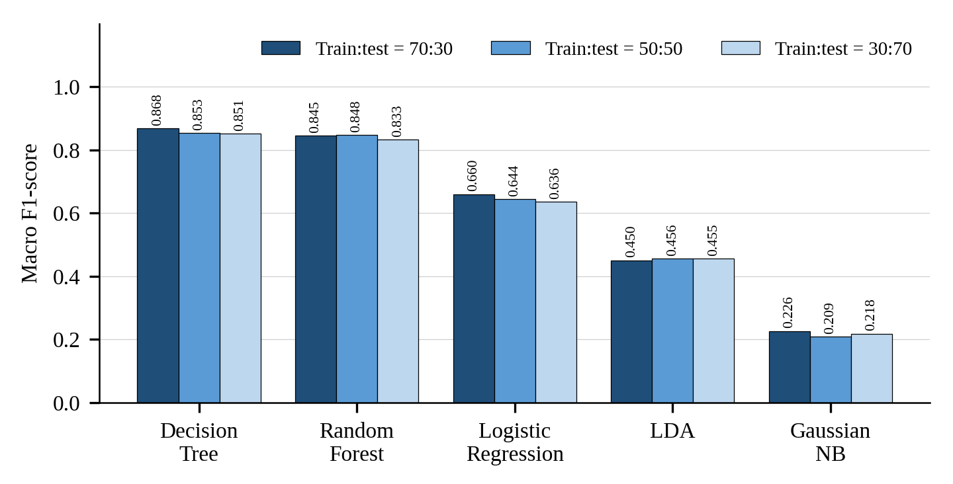
Fig. 8. Macro F1-score of all 15 executions. Macro averaging gives every class equal weight.

4.2 Discussion
Best algorithm. The Decision Tree achieved the highest accuracy, 99.90% at the 70:30 and 50:50 splits, and also the highest macro F1-score, 0.868 at 70:30. Random Forest matched the accuracy at 50:50 (99.90%) but its macro F1-score was lower in every run (0.833-0.848). With only 50 trees, the forest did not improve on a single tree, and a gain of 0.01 percentage points is far smaller than the run-to-run variation one would expect from a different random seed. The two tree models are therefore equal in accuracy, and the Decision Tree is preferable because it is simpler, faster and slightly better on rare classes.
Weaker models. Logistic Regression reached 98.1-98.2% accuracy but only 0.64-0.66 macro F1: at the 70:30 split it assigned almost every web-attack flow to BENIGN (recall 0.00, 0.00 and 0.01 for Brute Force, SQL Injection and XSS) and recognised only half of the SSH-Patator flows (Fig. 9). LDA reached about 90.6-90.9% accuracy and 0.45 macro F1, and found only one third of slowloris flows. Gaussian Naïve Bayes was the weakest model, with about 30% accuracy; it labelled only 20% of benign traffic correctly and spread the rest over many attack classes. Its weighted precision (0.92-0.94) looks high, but it is dominated by large classes and should not be read as good performance. LDA has a higher macro recall (0.65-0.67) than Logistic Regression (0.62-0.64) but a much lower macro precision, which means it finds more rare attacks at the price of many false alarms.
Underfitting and overfitting. For Logistic Regression, LDA and Naïve Bayes the train and test errors are almost identical (for example 0.0177 and 0.0179 for Logistic Regression at 70:30), so the error comes from model bias rather than from too little data: these linear or probabilistic models cannot represent the class boundaries. For the tree models the train error is 0.0001 and the test error about 0.001; the gap is small in absolute terms, so there is no serious overfitting even though the trees are unpruned.
Effect of the split ratio. Reducing the training share from 70% to 30% changes the accuracy of the tree models by only 0.01 percentage points (Decision Tree 99.90% to 99.89%) and of Logistic Regression by 0.10 points. Macro F1 is more sensitive: it falls from 0.868 to 0.851 for the Decision Tree and from 0.660 to 0.636 for Logistic Regression, because less training data leaves fewer examples of the rare classes. The ranking of the five algorithms never changes.
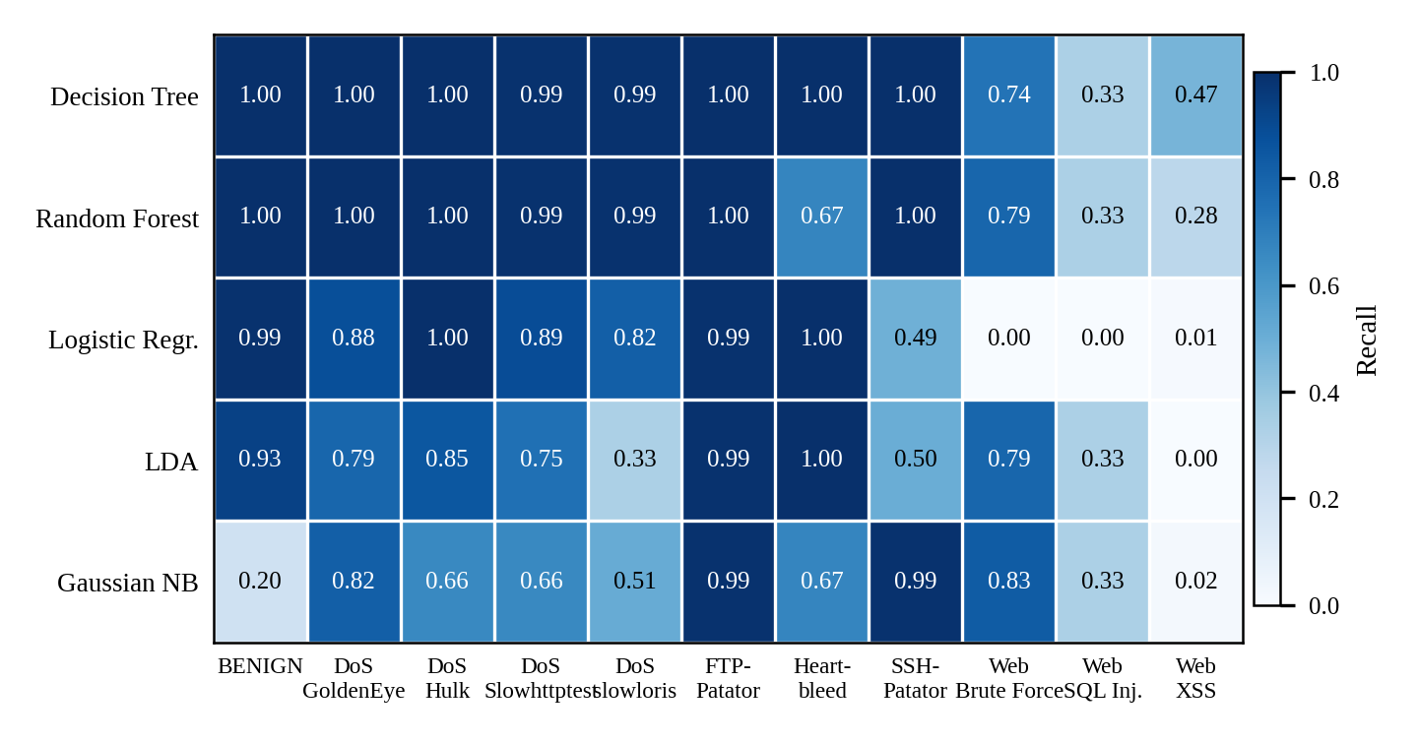
Fig. 9. Per-class recall of the five algorithms at the 70:30 split, read from the row-normalised confusion matrices.
Per-class behaviour. Fig. 9 shows that the tree models recognise all DoS, FTP-Patator and SSH-Patator classes almost perfectly (recall 0.99-1.00). Their remaining errors lie in the web attacks. At 70:30 the Decision Tree finds 74% of Brute Force flows but sends 24% of them to XSS, and finds only 47% of XSS flows while sending 52% to Brute Force; the two attacks produce very similar flow statistics. SQL Injection has too few test flows for a stable estimate (recall 0.33 for four of the five models), and Heartbleed recall of the Random Forest varies between 0.67 and 1.00 across the splits for the same reason. These very rare classes explain why macro F1 stays near 0.85 although accuracy is 99.9%.

4.3 Comparison with the best published results
Fig. 10 compares the best accuracy of the proposed work with the five best papers of Table 1. The Decision Tree result of 99.90% is on par with the best reported values, 99.88% [7,13] and 99.87% [3], and slightly above the 99.80% of [9] and the 99.60-99.64% of [8]; it is also above the 99.6% of [2] and the 99.3% of [5]. Differences of 0.02-0.03 percentage points are within the variation that a different data split or seed can cause, so the result should be read as comparable to the state of the art, not as clearly better. Two points must be kept in mind. The cited papers use different subsets of CICIDS2017 (and the abstract of [13] does not name its dataset), different class definitions (binary or multi-class), feature selection, resampling and validation schemes, so the numbers are not strictly comparable. In addition, the proposed pipeline uses no feature selection or resampling, which makes it simple, but its macro F1-score of 0.87 shows that rare web attacks remain unsolved.
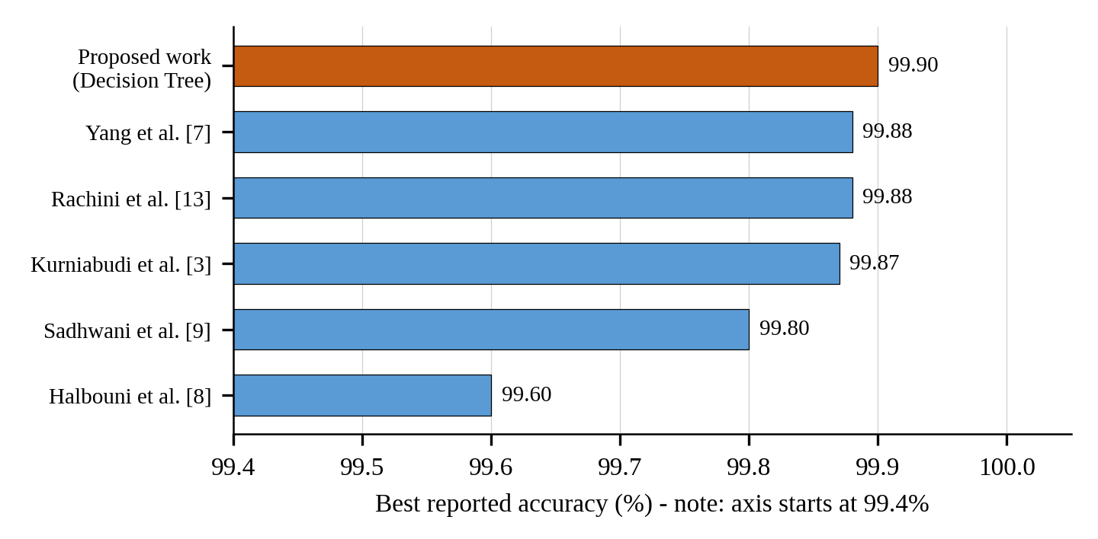
Fig. 10. Best accuracy of the proposed work compared with the five best papers of the literature survey.

4.4 Limitations
The results come from three of the five CICIDS2017 days, one random seed and a random stratified split. Flows from the same attack session are often near-duplicates, so a random split may put similar flows in both the training and the test part and make the tree models look better than they would on new traffic; a time-based split would be stricter. The dataset also contains labelling errors [6], and the Random Forest uses only 50 trees. No hyper-parameter tuning, feature selection or resampling was applied.

5 Conclusion
This paper compared Decision Tree, Random Forest, Logistic Regression, Linear Discriminant Analysis and Gaussian Naïve Bayes for 11-class intrusion detection on about 1.3 million CICIDS2017 flows, using three train-test ratios (15 runs) and a common pre-processing pipeline. The Decision Tree produced the best result, 99.90% accuracy and a macro F1-score of 0.868 at the 70:30 split, with Random Forest equal in accuracy (99.90% at 50:50) but lower in macro F1-score; Logistic Regression (98.2%), LDA (90.9%) and Gaussian Naïve Bayes (30.2%) were clearly weaker and underfitted, and the train-test ratio changed accuracy by at most 0.1 percentage points. The best accuracy is comparable to the 99.6-99.9% reported in the five best IEEE Xplore papers reviewed, but class-level analysis shows that the Brute Force, XSS and SQL Injection web attacks are still poorly separated by every model, so future work should apply resampling, feature selection and time-based validation to improve rare-class detection.

References
1. Ustebay, S., Turgut, Z., Aydin, M.A.: Intrusion detection system with recursive feature elimination by using random forest and deep learning classifier. In: 2018 International Congress on Big Data, Deep Learning and Fighting Cyber Terrorism (IBIGDELFT), Ankara, Turkey. IEEE (2018)
2. Abdulhammed, R., Faezipour, M., Musafer, H., Abuzneid, A.: Efficient network intrusion detection using PCA-based dimensionality reduction of features. In: 2019 International Symposium on Networks, Computers and Communications (ISNCC). IEEE (2019). https://doi.org/10.1109/ISNCC.2019.8909140
3. Kurniabudi, Stiawan, D., Darmawijoyo, Idris, M.Y.B., Bamhdi, A.M., Budiarto, R.: CICIDS-2017 dataset feature analysis with information gain for anomaly detection. IEEE Access 8, 132911-132921 (2020). https://doi.org/10.1109/ACCESS.2020.3009843
4. Maseer, Z.K., Yusof, R., Bahaman, N., Mostafa, S.A., Foozy, C.F.M.: Benchmarking of machine learning for anomaly based intrusion detection systems in the CICIDS2017 dataset. IEEE Access 9, 22351-22370 (2021). https://doi.org/10.1109/ACCESS.2021.3056614
5. Das, S., Saha, S., Priyoti, A.T., Roy, E.K., Sheldon, F.T., Haque, A., Shiva, S.: Network intrusion detection and comparative analysis using ensemble machine learning and feature selection. IEEE Trans. Netw. Serv. Manag. (2021). https://doi.org/10.1109/TNSM.2021.3138457
6. Engelen, G., Rimmer, V., Joosen, W.: Troubleshooting an intrusion detection dataset: the CICIDS2017 case study. In: 2021 IEEE Security and Privacy Workshops (SPW), pp. 7-12. IEEE (2021)
7. Yang, L., Moubayed, A., Shami, A.: MTH-IDS: a multitiered hybrid intrusion detection system for Internet of Vehicles. IEEE Internet Things J. (2021)
8. Halbouni, A., Gunawan, T.S., Habaebi, M.H., Halbouni, M., Kartiwi, M., Ahmad, R.: CNN-LSTM: hybrid deep neural network for network intrusion detection system. IEEE Access 10, 99837-99849 (2022)
9. Sadhwani, S., Harish, A., Muthalagu, R.M., Pawar, P.M.: A lightweight model for detecting cyberthreats using machine learning techniques. In: 2024 Advances in Science and Engineering Technology International Conferences (ASET), Abu Dhabi. IEEE (2024). https://doi.org/10.1109/ASET60340.2024.10708693
10. Karatas, G., Demir, O., Sahingoz, O.K.: Increasing the performance of machine learning-based IDSs on an imbalanced and up-to-date dataset. IEEE Access 8, 32150-32162 (2020). https://doi.org/10.1109/ACCESS.2020.2973219
11. Liu, L., Wang, P., Lin, J., Liu, L.: Intrusion detection of imbalanced network traffic based on machine learning and deep learning. IEEE Access 9, 7550-7563 (2021). https://doi.org/10.1109/ACCESS.2020.3048198
12. Ogodo, O.E., Osa, E.: Comparative analysis of machine learning models in computer network intrusion detection. In: 2022 IEEE NIGERCON. IEEE (2022). https://doi.org/10.1109/NIGERCON54645.2022.9803175
13. Rachini, A., et al.: AI-powered network intrusion detection: a new frontier in cybersecurity. In: 24th International Arab Conference on Information Technology (ACIT 2023). IEEE (2023)
14. Ali, Z., Tiberti, W., Marotta, A., et al.: Empowering network security: BERT transformer learning approach and MLP for intrusion detection in imbalanced network traffic. IEEE Access (2024). https://doi.org/10.1109/ACCESS.2024.3465045
15. Pavithra, S., et al.: Detecting unbalanced network traffic intrusions with deep learning. IEEE Access (2024). https://doi.org/10.1109/ACCESS.2024.3405187

